Oregon Area
Al-Anon/Alateen
Family Groups

GROUP REPRESENTATIVE

QUICK REFERENCE

GUIDE – 2022

TABLE OF CONTENTS

Reference Tools Page 02
Group Contact Information Page 02
Area Contact Information Page 03
Links of Service Page 04
Acronyms Page 05
Statement to Assembly Page 06
General Assembly Procedures Page 07
District Map Page 08
KBDM Procedures Page 09
Expenses/Financial Page 10
Ask it Basket Page 11
Notes Page 12
REFERENCE TOOLS

- The Al-Anon/Alateen Service Manual (P-24/27) is a digest of Al-Anon policy provided to the groups and published by WSO. Copies are available online at the WSO Member’s website or for purchase at your local AIS office or local Literature Depot.

- The Oregon Area Handbook (OAH) was created by and for the Oregon Area and is to be used in conjunction with the Al-Anon/Alateen Service Manual, WSO Guidelines and Conference Approved Literature (CAL).
See www.oregonal-anon.org/oregon-area-handbook.

- The difference between the OAH and the SM is that the SM is for all Al-Anon/Alateen members whereas, the OAH only refers to the Oregon Area

- FAQ’s are listed on Oregon Area Website

GROUP CONTACT INFORMATION

My WSO Group Number is: My District is:

My District Representative is:
Phone Number:
Email:

My District Meeting is held at:

My District Meeting is held on:

My District Email Address is:

My Area is: OREGON

OREGON AREA CONTACT INFORMATION

My Area Delegate is:
Email: Oregon-delegate@OregonAl-Anon.org
My Area Alternate Delegate is:
Email: alternateoregon-delegate@oregonal-anon.org
My Area Chairperson is:
Email: chair-person@oregonal-anon.org
My Area Treasurer is:
Email: treasurer@oregonal-anon.org
My Area Secretary is:
Email: secretary@oregonal-anon.org
My Area Alateen Process Person is:
Email: alateen_process_person@oregonal-anon.org
My Area Archives Coordinator is:
Email: archives@oregonal-anon.org
My Area Alateen Coordinator is:
Email: alateen@oregonal-anon.org
My Area Group Records Coordinator is:
Email: group-records@oregonal-anon.org
My Area CPC Coordinator is:
Email: cpc@oregonal-anon.org
My Area Literature Coordinator is:
Email: literature@oregonal-anon.org
My Area Forum Coordinator is:
Email: forum@oregonal-anon.org
My Area Public Outreach Coordinator is:
Email: publicinfo@oregonal-anon.org
My Area Technology Coordinator is:
Email: technology@oregonal-anon.org
My Area Website Coordinator is:
Email: website@oregonal-anon.org

Oregon Area website address: www.oregonal-anon.org
The Oregon Area Handbook is on website to download in pdf format.

WSO website address: www.al-anon.org

WSO Member’s website address: www.al-anon.org/members/
Guidelines and Service Manual are available to download in pdf format.
LINKS OF SERVICE

Groups Help and Serve Members…
Members help and service the Group.

Groups: Al-Anon and Alateen membership is open to anyone who feels their life has been affected by someone’s drinking.

Members join local groups and share the Al-Anon program and participate in group service.

Group Representatives (GRs) are a vital link in the continuing function, growth and unity of worldwide Al-Anon.

Members in a group elect a GR who acts as a liaison between the group and the district and between the group and the Area Assembly.

District Representatives (DRs) are an important link between the groups and the Area.

GRs in a district elect a DR. The DR chairs the district meeting, represents the groups in their district at Area World Service Committee (AWSC) meetings and serves as a resource and information source for the groups.

Area World Service Committee (AWSC) meetings are held at regularly scheduled intervals. It consists of the Assembly Officers, DRs, Area Coordinators and liaison members, who meet between Assemblies to discuss Area and district matters, plan the agenda for the Assembly, initiate projects and make recommendation to the Assembly.

GRs at the Area Assembly elect an Area Delegate to the annual World Service Conference, an Alternate Delegate and Assembly Officers.

Area Delegates are the link between the groups and the World Service Conference, which is held annually, as well as the World Service Office.
ACRONYMS
AAC Area Alateen Coordinator
AAPP Area Alateen Process Person
AFA Al-Anon Faces Alcoholism (Magazine for Professionals)
AFG Al-Anon Family Group
AIS Al-Anon Information
AMIAS Al-Anon Member Involved in Alateen Service
ATF Area Travel Fund
AWSC Area World Service Committee
CAL Conference Approved Literature
CMA Current Mailing Address
CPC Cooperating with the Professional Community
DR District Representative
GR Group Representative
GSO General Service Office (for Other National Countries)
LDC Literature Distribution Center
ISR Information Service Representative
KBDM Knowledge Based Decision Making
NWRDM North West Regional Delegates Meeting
NWRT North West Regional Trustee
OAC Oregon Alateen Conference
ODAT One Day at a Time
OAH Oregon Area Handbook
PI Public Information
PO Public Outreach
PSA Public Service Announcement
SM Service Manual
SSM State Speakers Meeting
WSC World Service Conference
WSO World Service Office

STATEMENT TO ASSEMBLY

Bring your Al-Anon/Alateen Service Manual (P-24/27)
- Assemblies are held in the months of March, July and November.
- Assembly runs all day Saturday and until Noon on Sunday.
- Before each Assembly, an agenda is posted on the Oregon Area Website. The agenda states what will be discussed and voted on.
- Arrive on time so that the Assembly can start promptly.
- When you arrive, sign in. There are two sign-in sheets. All attendees sign the attendance sheet; only voting members (GR’s or an alternate) sign the voting sheet.
- All Assembly attendees wear a badge. Most badges are previously prepared and available at the assembly. Group Representatives wear Blue Badges; AWSC members wear Yellow Badges; and guests & visitors wear White Badges.
- Only Group Representatives or their alternates have voice and vote at an Assembly. There is only one vote per group.
- AWSC members (Officers, Coordinators, AIS Liaisons, District Representatives, Past Delegates, and Audit Budget Committee) have only voice at an Assembly unless also a Group Representative.
- If you are a visitor or a guest without voice, please ask your Group or District Representative to speak for you.
- Your vote is important; be present during voting. GRs were counted on the Voting Sheet and if you’re not present during voting this disrupts the count and will delay the meeting.
- Only one visit to the microphone per topic. You may return to the microphone if you have a question, but not to make another point.
- If your opinion has already been stated – do not repeat it again.
- Time at the microphone should be kept to 2 minutes.
- If you have a question during a discussion, go to the microphone and raise your WSO Service Manual.
- When people are at the microphone voicing an opinion, refrain from applause or other forms of audible response as a courtesy to others whose opinion might differ from yours.
- Only one conversation should be going on at a time. If you need to communicate with someone, please use scratch paper to do so.
- If you do not have a Service Sponsor, speak to an AWSC member for more info. Also see Service Sponsorship Pamphlet (P-88).
- If you have a general question, complete the Ask It Basket Form found on your table.
- The people at the front table are the Oregon Area Officers.
- Cell phones and other electronic devices should be silenced.
- No pets are allowed. Service animals are permitted.

GENERAL ASSEMBLY PROCEDURES

Agenda
- The agenda is derived from input through members of the Area World Service Committee (AWSC). Suggestions from all members and the membership-at-large are carefully considered. Using the Links-of-Service by contacting your District Representative first and having a discussion at your District meeting prior to the subject being brought to AWSC is strongly recommended.
- The Chairperson can alter the agenda if circumstances warrant. However, any significant deviation from the agenda initiated by the Chairperson or any other member with voice requires a two-thirds vote.

Tips, Hints, and Words of Caution
- In a Knowledge-Based culture, full discussion of an idea takes place before a motion is presented.
- The legitimate rights of the minority are protected by Concept Five (“The rights of appeal and petition protect minorities and insure that they be heard”) and are observed throughout our proceedings.
- It is important to remember that the purpose of our procedures is to make it easier for us to conduct business; procedures exist to allow us to do what needs to be done in order to carry out the will of the fellowship by reaching an informed group conscience.
- Voting by show of hands or closed ballot is decided by the Area Chairman.
- Out of deference to those holding a minority viewpoint, applause is discouraged when a member expresses an opinion with which others may agree.

Asking for a Consensus
- At times, there is a need for a consensus to obtain a sense of direction before moving forward. When a consensus is requested, the Chairman asks for a show of hands indicating “yes” or “no” expression from the members. Since this is not a formal vote, closed ballots are not necessary.

Substantial Unanimity
- What constitutes substantial unanimity is decided at the beginning of each Assembly and AWSC.

Warranty Three: That all decisions be reached by discussion, vote and whenever possible by unanimity
- The practical and spiritual results of substantial unanimity will make itself evident.

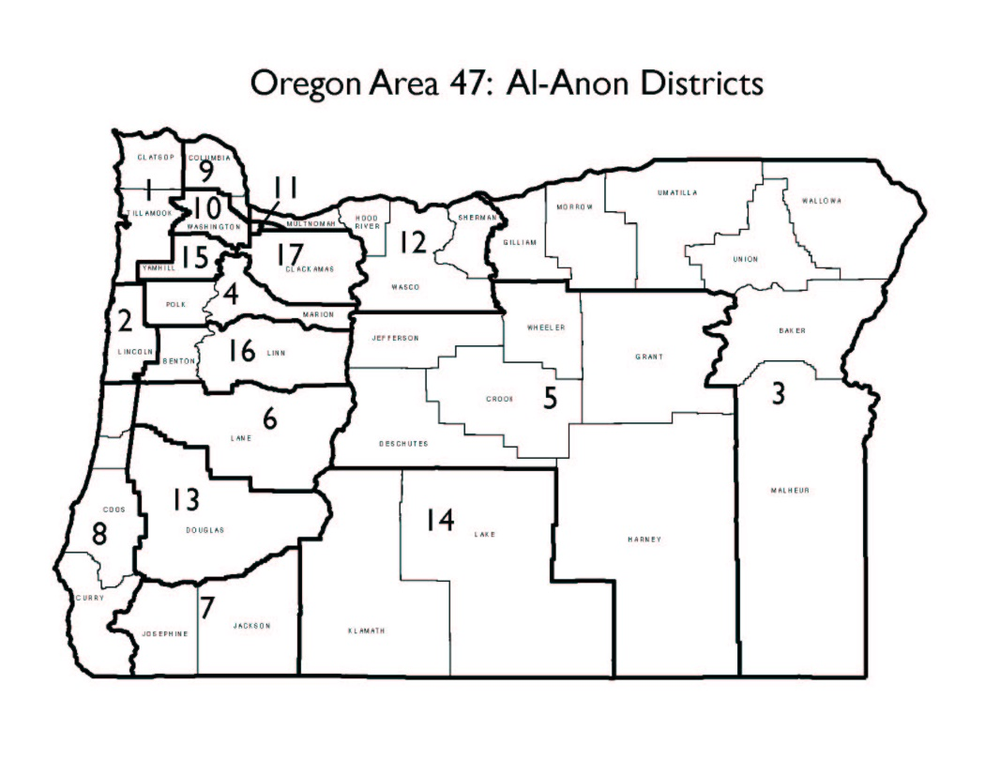
MAP OF OREGON AREA DISTRICTS

1-Clatsop and Tillamook Counties

2-Lincoln County

3-Gilliam, Morrow, Umatilla, Wallowa, Union, Baker and Malheur Counties

4-Marion and Polk Counties

5-Grant, Harney, Crook, Jefferson, Wheeler and Deschutes Counties

6-Lane County East

7-Josephine and Jackson Counties

8-Curry, Coos, Lane(West) and Douglas(West) Counties

9-Columbia and Multnomah(West) Counties
10-Washington, Clackamas(West) and Multnomah(South) Counties

11-Multnomah County East

12-NE Multnomah, Sherman, Wasco and Hood River Counties

13-Douglas County and Scottsburg

14- Klamath and Lake Counties

15-Yamhill County

16-Linn and Benton Counties

17-Clackamas County East and West Linn

KBDM PROCEDURE
How to gather information to make an Informed Group Conscience?

In a Knowledge-Based Decision-Making (KBDM) environment, ideas are brought to the Chairperson for AWSC agenda consideration through the links of service. The Chairperson may appoint a thought force to gather supporting information including background and a completed KBDM Questionnaire. When the thought force reports back to AWSC, it will be determined whether to go forward, to gather more information, assign a task force, or proceed with a motion. (See the procedures for making motions on Page 14?)

The KBDM Questions

Versions of the KBDM Questions are listed below. For further information and details, please see references in Al-Anon/Alateen Service Manual, version two (2), pgs. 70-72 including the footnote on page 70].

Question 1
What do we know about our members’ or prospective members’ needs that is relevant to this discussion? [What do we know about what our members need and want?]
Question 2
What do we know about the resources and our vision for the organization that is relevant to this discussion (finances, membership participation)? [What do we know about our resources and capacity?]
Question 3
What do we know about the current realities (membership, culture), evolving dynamics of the world and our fellowship’s environment (technology, our Legacies and spiritual principles) that is relevant to this discussion? [What are the Pros and Cons? What do we know about what’s currently happening within our groups?]
Question 4
What are the ethical implications of our choices (pros and cons)?
In other words, will our decision be consistent with our spiritual principles? [Will our decision be consistent with our spiritual principles?]
Question 5
What do we wish we knew, but don’t? [What else do we need to know before moving forward?]
EXPENSES/FINANCIAL

- The information required on a contribution check:
  - Group Name
  - Group WSO number
  - District Number
Please pass this info to your group treasurer.

- Group funds remaining after group expenses may be divided between WSO, Area, District and Al-Anon Information Services (AIS) according to SM, Pg. 56-7; Seventh Tradition pamphlet; and Oregon Area Handbook (OAH), Section IV, Pgs. 9-10.

- The expenses for a Group Representative (GR) to attend an assembly (gas, food, lodging, donation to Area) are paid by the group. See SM Pg. 56, 158-159.

- If your group cannot afford assembly expenses, see OAH, Section IV, Pg. 3 and check with your district.

- The mailing address for DISTRICT CONTRIBUTIONS:

- The mailing address for AREA CONTRIBUTIONS:

- The mailing address for Al-Anon Information Service or Literature Distribution Center (AIS/LCD):

- The mailing address for WORLD SERVICE OFFICE:

Al-Anon Family Group Headquarters, Inc
1600 Corporate Landing Parkway
Virginia Beach, VA 23454-5617
Telephone: 757-563-1600
Make Checks out to AFG, Inc.

ASK IT BASKET

If you have a general question during the assembly, complete the Ask It Basket Form found on your table. Once completed, if you still have an unanswered question, place the form in the Ask-It-Basket on the Officers Table.

Questions may be about the following:
- Group situations or problems
- Questions coming from the Assembly business meeting
- General questions about the Assembly weekend

1. Is your question stated clearly? Is it legible and respectful?
2. Did you review this with a friend? ____Yes ____No
3. I looked for an answer in the Service Manual on pages
.
- I looked for an answer in the Oregon Area Handbook on pages
.

NOTES

